 

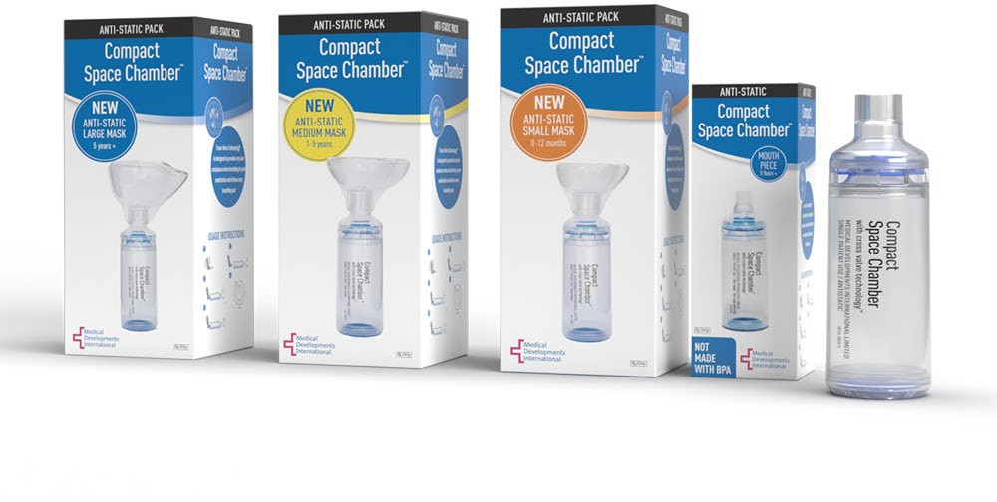[www.medicaldev.com](http://www.medicaldev.com/) [www.spacechamber.com](http://www.spacechamber.com/)

The respiratory product category spans across both the non-acute and acute space to include patients with COPD and/or asthma and is nondiscriminatory across all ages, sex, education levels and economics. The respiratory product line is utilized in both acute and nonacute spaces across DME, LTC, Skilled Nursing, IDN, and GPOs.

Medical Developments International is a Global manufacturer penetrating the US Market and offers the following:

* Full line of patented high quality and low-cost respiratory devices for use with an Asthma/COPD Inhaler.

The benefits the anti-static Compact Space Chamber and anti-static silicone face mask include:

* + Proprietary low resistance, Cross Valve Technology TM – visible valve action - through a transparent chamber.
  + Anti-static mask fits infants, children, and adults available in S, M, L standard 22mm diameter fitting.
  + All masks and chambers are interchangeable, and no priming required before use.
  + BPA free, dishwasher safe, and 1 year manufacturer guarantee.
  + Covered by 98% of Commercial, Medicaid and Medicare with in-stock availability.

|  |  |  |  |  |  |  |  |  |
| --- | --- | --- | --- | --- | --- | --- | --- | --- |
|  | **Product (Generic) Name** | **Size** | **Units** | **UPC#** | **CONCORDANCE ORDER #** | **WAC** | **Case WAC** | **Concordance** |
| Ten percent discount off  WAC | | | | | | | | |
| Compact SC -Antistatic- US- chamber only | Space Chamber™  Brand | 1 | 48 | 842135100008 | **401706** | $5.40 | $259.20 | $4.86 |
| Compact Combo Pack and Antistatic Small Silicone Mask | Space Chamber™  Brand | 1 | 24 | 842135100084 | **401715** | $12.95 | $310.80 | $11.66 |
| Compact Combo Pack and Antistatic Medium Silicone Mask | Space Chamber™  Brand | 1 | 24 | 842135100091 | **401718** | $12.95 | $310.80 | $11.66 |
| Compact Combo Pack and Antistatic Large Silicone Mask | Space Chamber™ Brand | 1 | 24 | 842135100107 | **401721** | $13.70 | $328.80 | $12.33 |
|  |  |  |  |  |  |  |  |  |

  *******A copy of the customer’s RX license must be on file since an RX is required. ************

Contact: Stephanie Hall

National Key Account Manager Institutions [shall@medicaldev.com](mailto:shall@medicaldev.com) 803 - 220 - 6144