Conventional Luer Lock Syringe Promo
WHEN YOU BUY THIS:

1ML Syringe – 3 Boxes
3ML Syringe – 3 Boxes
5ML Syringe – 3 Boxes
10ML Syringe – 3 Boxes
20ML Syringe – 3 Boxes
30ML Syringes – 3 Boxes
60ML Syringes – 3 Boxes
1ML Syringe – 1 Box
3ML Syringe – 2 Boxes
5ML Syringe – 2 Boxes
10ML Syringe – 2 Boxes
20ML Syringe – 1 Box
30ML Syringes – 1 Box
60ML Syringes – 1 Box

YOU GET THIS FREE:
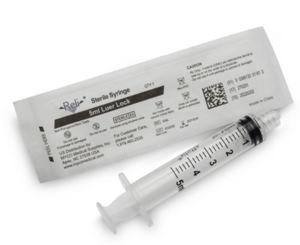

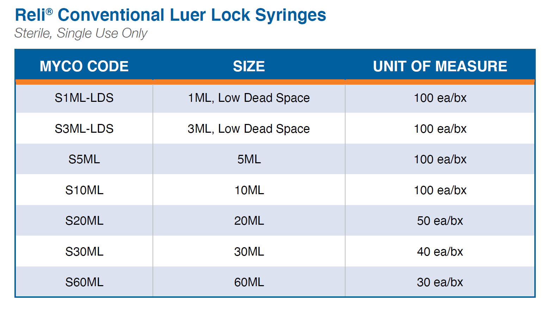
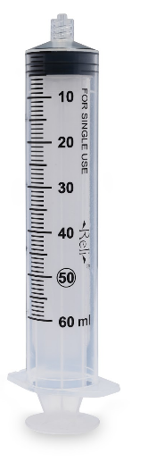
TERMS
- FREE product shipped directly to the end user.
- Promotion runs through December 31, 2024.
- FREE samples upon request. Email: SampleRequests@MYCOMedical.com

