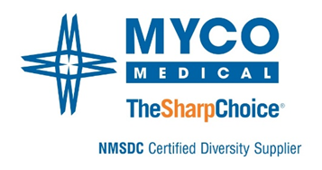

Announcement: Tom Carter

MYCO Medical is pleased to announce the newest member of our management team, Tom Carter, Product Manager- Wound Closure. Tom will lead the product management activities for all sutures and other wound closure products in the non-acute and acute care markets. He will focus on expanding and refining the product mix to meet the demands of these markets. Tom comes to MYCO with over 25 years of medical device experience in product management, marketing, business development, and product training. For the past 11.5 years, Tom has worked for a leading spinal implant company managing their product portfolio, training, and surgical support. Tom holds a Master of Health Administration from Saint Louis University, St. Louis, MO and a bachelor’s degree in health management, and associate degree in respiratory therapy from Southern Illinois University, Carbondale, Illinois. He is a current North Carolina Licensed Registered Respiratory Therapist.

To learn more about the MYCO RELI® Suture Brand, please contact Tom Carter at [tcarter@mycomedical.com](mailto:tcarter@mycomedical.com) or his mobile # at 574-527-7745.

Visit the MYCO Team: [www.mycomedical.com](http://www.mycomedical.com)