

A New Opportunity Comes to Light

Better Lighting + Convenient Kits
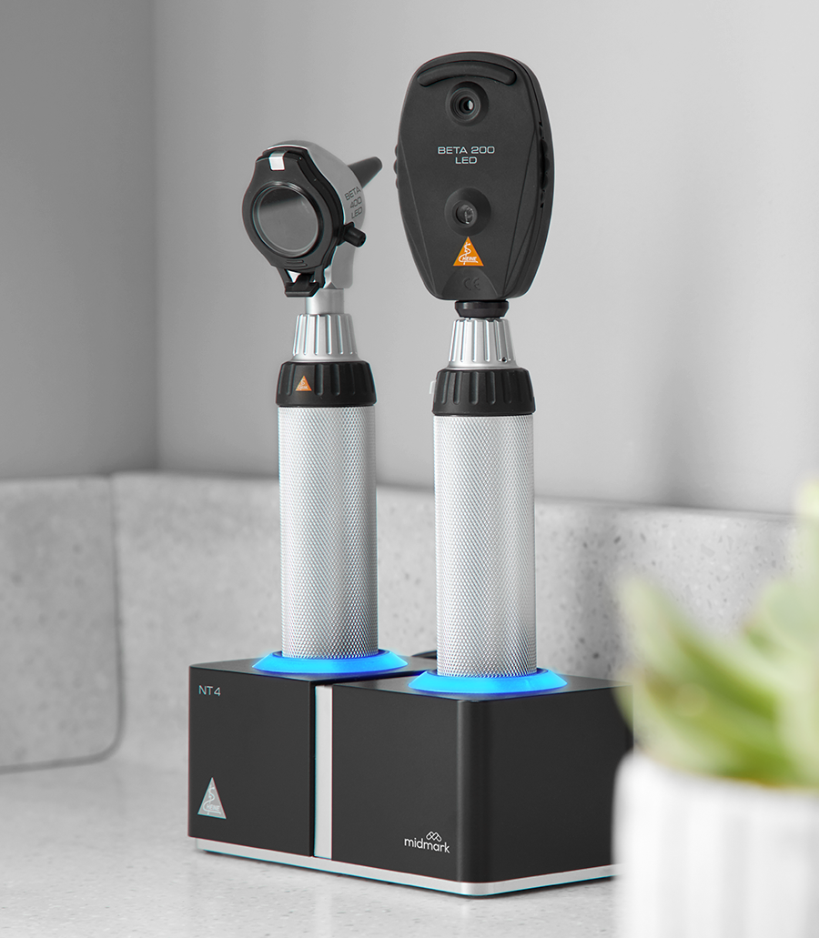
Your customers deserve exam solutions that work as hard as they do. That’s why all Midmark HEINE Diagnostic Instruments now come standard with exclusive LED^{HQ} illumination—brighter, more reliable and maintenance-free. Even better, we’ve bundled the essential diagnostic tools customers need into customizable wall set kits.

NEW Midmark HEINE® Instrument Wall Set Kits
Help your customers make smarter investments in diagnostic care.
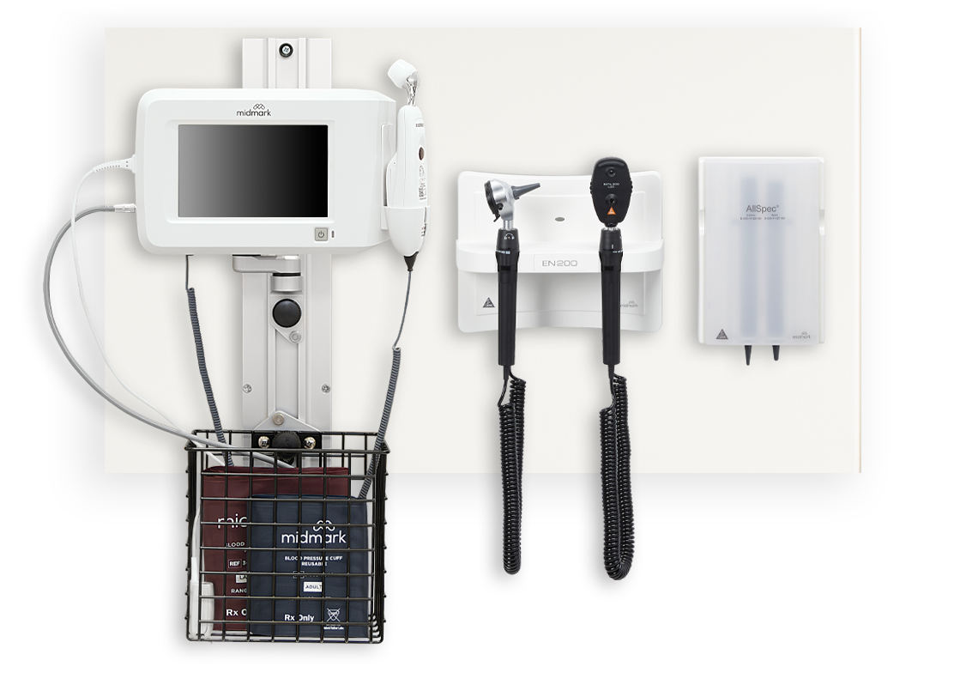
- Easy to order with all-in-one components
- Available in 12 configurations to meet customers’ needs
- Built to last with less maintenance
SEE THE KITS

  Interested in making a purchase?
  Tell us how to contact you and we’ll be in touch with more details.
  CONTACT US
  

Privacy Policy | Contact Us | 1.800.MIDMARK
We're contacting you because, as an existing or potential customer, we'd like to keep you informed about our products and solutions. To unsubscribe from similar communications, click here.
 |  |  |  |  |  |  |  | 

© 2024 Midmark Corporation, 60 Vista Dr, Versailles, Ohio 45380 USA

