January 20,2025
Dear Customer,

We are writing to inform you of the discontinuation of part number 75-0017-0000 effective immediately. This product has been replaced with part number AVTL-5005-0000.

There are some differences in the AVTL-5005-0000 compared to the 75-00017-000 and we wanted to communicate those to existing customers to understand the impact.

- Blade form, fit, and function remain the same. This product still utilizes a 2 blade razor head, 3 facet, Stainless Steel, Coated, and Oiled blade.
- Case size remains the same. 10 razors per bag, 10 bags per case.
- Improvements within the cartridge head include changes to the blade design and guard bar.
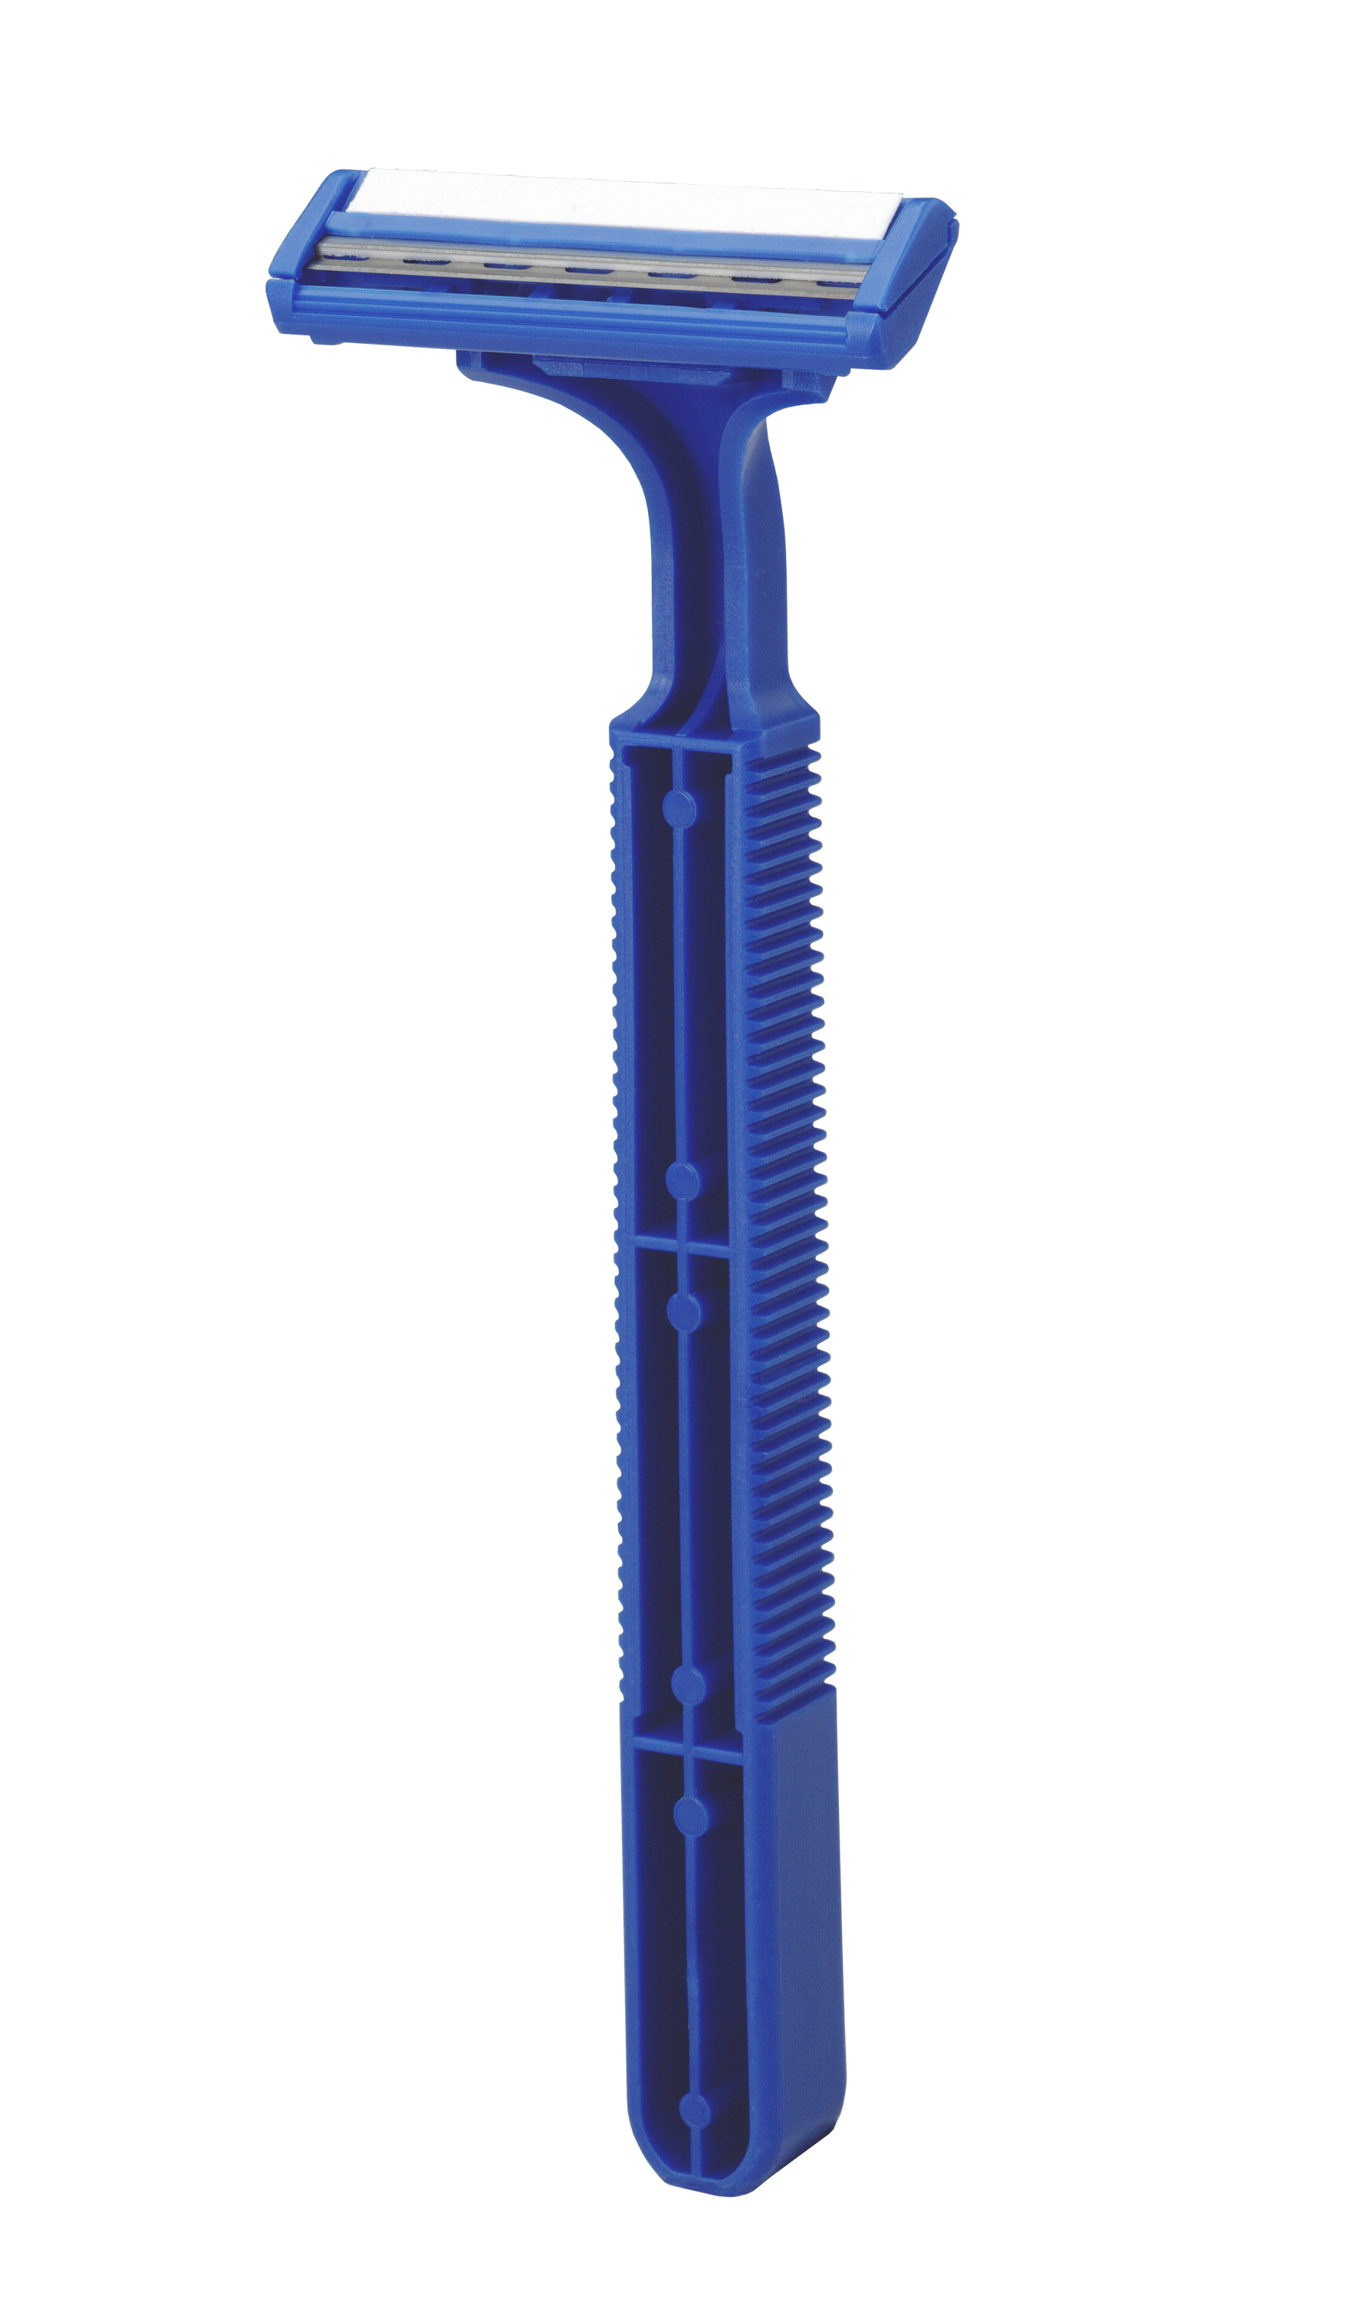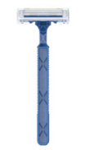
75-0017-0000 (discontinued) AVTL-5005-0000 (new)

Thank you for your continued support, and we sincerely appreciate your business.

Garnett A. Andes
Garnett A. Andes
Product Manager
AccuTec, Inc.

