August 7, 2025

Product Notice: Labeling Update, SANDEL™ STAT-STRAP™ Patient Safety Straps

Dear Valued Partner,

We would like to inform you that we have updated the labeling for our SANDEL™ STAT-STRAP™ Patient Safety Straps to include a caution statement and a QR code leading to the product instructions for use (IFU).

The QR codes below can be used to view the IFUs for the STAT-STRAP™ straps.

Item Number | QR Code for IFU
TS-10, TS-SM, TS-SS, TS-PD, TS-RD | 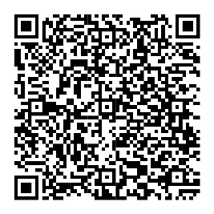

If you have any questions, please contact your local Ansell Territory Manager or Ansell Customer Service at 800-952-9916. Thank you for your continued loyalty and support.

Sincerely,

The Ansell Team

