July 1, 20224

GAMMEX® PI PLUS GLOVE-IN-GLOVE SYSTEM – REMINDER ON PRODUCT ITEM CODES FOR 2024 AND BEYOND
Dear Valued Customer,
We are writing to remind you that the new GAMMEX PI Plus Glove-In-Glove System is now available. As a reminder, this updated configuration is an upgrade from the previous GAMMEX® PI Glove-in-Glove System. While this is still the world’s ONLY pre-donned glove-in-glove system that includes two gloves pre-donned together into one unique product with unparalleled comfort and fit, the new GAMMEX® PI PLUS Glove-in-Glove System also includes Ansell’s proprietary
PI KARE™ Skin-Friendly, Non-Sensitizing PI Technology to address ongoing Type IV chemical allergy concerns. In addition, the top glove now features a textured finish for exceptional instrument handling and grip.
REMINDER: This the world’s ONLY pre-donned glove-in-glove system. See below for the quick & easy donning process:
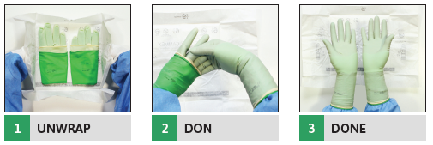 |  |  | 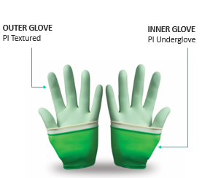

The discontinued version of the GAMMEX® PI Glove-In-Glove System is no longer available for order placement as all stock has been depleted in Ansell warehouses. Below please see the new ordering information to update your systems accordingly. All future orders should utilize the new GAMMEX® PI Plus Glove-In-Glove™ System items numbers as noted.
REMINDER: DISCONTINUED PRODUCT |  |  | REMINDER: NEW/REPLACEMENT SKUs
GAMMEX® PI Glove-In-Glove™ System |  |  | GAMMEX® PI Plus Glove-In-Glove™ System
Size | Item Number |  | Size | Item Number
5.5 | 340084055 |  | 5.5 | 340082055
6.0 | 340084060 |  | 6.0 | 340082060
6.5 | 340084065 |  | 6.5 | 340082065
7.0 | 340084070 |  | 7.0 | 340082070
7.5 | 340084075 |  | 7.5 | 340082075
8.0 | 340084080 |  | 8.0 | 340082080
8.5 | 340084085 |  | 8.5 | 340082085
9.0 | 340084090 |  | 9.0 | 340082090
If you have any questions, please contact your local Ansell Channel Manager or Ansell customer service at 1-800-952-9916.
They will be able to assist you with updating your systems to the new item numbers if applicable for a smooth transition.

Please see the product comparison table on the next page for additional information on the transition over to the GAMMEX® PI PLUS Glove-In-Glove™ System. For more information on the GAMMEX® PI PLUS Glove-In-Glove™ System,
please visit www.ansell.com/gloveinglove.

Sincerely,

Melissa DeMarinis, MBA
Marketing – North America

Continued

PRODUCT COMPARISON REFERENCE GUIDE
 | REMINDER: GAMMEX® PI  Glove-In-Glove™ System | REMINDER: NEW GAMMEX® PI PLUS  Glove-In-Glove™ System
FEATURE
Ansell Surgical  Glove Combination | GAMMEX PI Hybrid (Outer)  GAMMEX Non-Latex PI Underglove (Inner) | GAMMEX Non-Latex PI Textured (Outer)  GAMMEX Non-Latex PI Underglove (Inner)
Material | Neoprene (Polychloroprene)/  Polyisoprene (PI) | Polyisoprene (PI)
Internal Glove Surface | DERMASHIELD® | DERMASHIELD®
External Surface Finishing | Smooth with micro-textured finish | Textured Fingers and Palm
Available Sizes | 5.5 to 9.0 | 5.5 to 9.0
Packing Configuration | 2 pairs per pouch | 2 pairs per pouch
 | 25 pouches boxes/carton | 25 pouches boxes/carton
 | 100 pouches/carton (200 pairs per case) | 100 pouches/carton (200 pairs per case)
Cuff Design | Beaded with SUREFIT™ Technology | Beaded with SUREFIT™ Technology
Allergy Protection | Latex (Type I) | Latex (Type I)  Chemical (Type IV) minimization with PI KARE Technology
Tested For Use With Chemotherapy Drugs | Yes, In Accordance with ASTM D6978  (Not Listed In The US FDA 510k) | Yes, In Accordance with ASTM D6978  (Not Listed In The US FDA 510k)
MBT/ZMBT-Free | Yes | Yes
Shelf-Life | 3 years | 3 years
Freedom From Holes (Inspection Level I) | 0.65 AQL | 0.65 AQL

Ansell, ® and ™ are trademarks owned by Ansell Limited or one of its affiliates. US Patented and US and non-US Patents Pending: www.ansell.com/patentmarking © 2024 Ansell Limited. All Rights Reserved.

