July 2024

Dear Valued Customer,

Aspen Surgical takes pride in the reliance you have placed on us to be your supplier. Our goal is to continue to focus on maintaining your trust and keeping you apprised of developments that may impact your business.

This letter is to inform you Aspen Surgical will be relocating the manufacturing site of the ALC Light Handle Covers we currently manufacture for you. In an effort to have better control of the manufacturing timeline and quality of the product, our ALC Light Handle Cover will now be fully manufactured at our production site in Caledonia, Michigan, including molding, packaging and labeling. Previously the parts were molded and assembled offshore and then packaged and labeled in Michigan.

As part of this project, we have also taken the time to add a few enhancements. For added securement, the lens is now molded directly into the device instead of a snap fit lens. The new lens material will also be switching to SBC (Styrolux) instead of the previously used PC (Poly Carbonate). The final change you may see is a slight color difference. Finally, if you are buying the LT-ALC01NS, please see the appendix for an updated shipping configuration. None of these changes will affect the function of the device or intended use.

**Part Numbers Affected:**

|  |  |
| --- | --- |
| **Part No** | **Part Description** |
| LT-ALC01 | Aspen Surgical's ALC Plus Disposable Light Handle Cover Sterile; 1/pouch; 18 pouches/box |
| LT-ALC01NS | Aspen Surgical ALC Plus Light Handle Cover; Non-Sterile; 72 eaches/box |

Should you have any further questions please do not hesitate to reach out your dedicated sales rep or our Customer Service Department at 888-364-7004, [customerservice@aspensurgical.com](mailto:customerservice@aspensurgical.com).

Thank you for your continued partnership,

Scott D. Latt

Senior Global Portfolio Manager

**Appendix**

The LT-ALC01NS will ship with two form-fitting foam layers along with additional layers of foam all wrapped in a poly bag to enable ever greater levels of protection during shipping (two layers of covers):

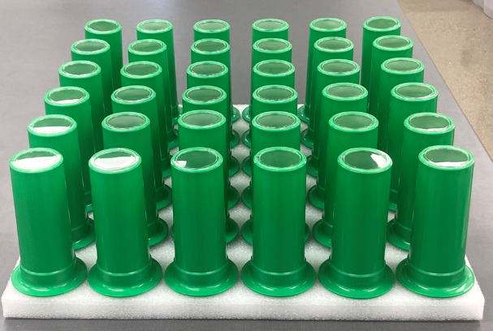

Torm-fitting foam layers

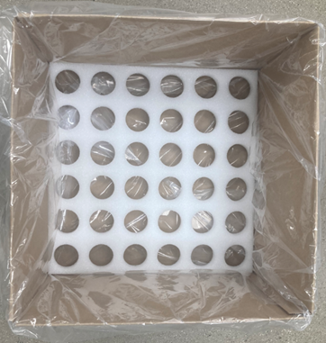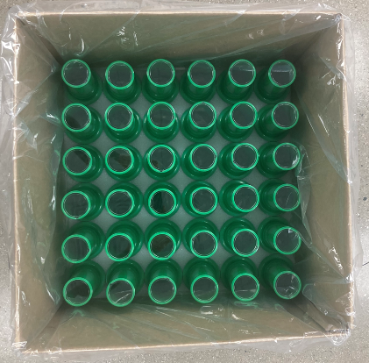

Additional foam layers

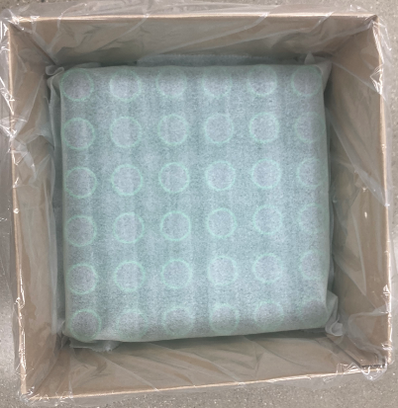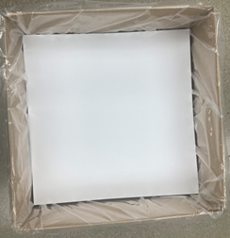

Box Dimensions and Weight will change:

|  |  |  |
| --- | --- | --- |
| **Box** | Current | Future |
| Height | 18.90” | 19.75” |
| Width | 13.39” | 19.75” |
| Depth | 21.66” | 13.375” |
| Weight | 13.7 lbs. | 9.7 lbs. |