July 1st, 2024
RE: Product Change (Product #s Listed Below)

Dear Valued Customer,

The Aspen Surgical Team will update the green Precept™ Surgical Face Masks and standardize their color and pattern to other face masks within the Infection Control portfolio. Due to the discontinuation of raw materials from our supplier, we have updated the color design for two of our face masks. The masks will be changed from green to green with a diamond print (see attached pictures below). This change standardizes the portfolio and streamlines supply chain processes for these products.

This change is purely aesthetic and does not affect form, fit, function, or price. It will take effect July 15th, 2024; however, with existing inventory, you may see examples of mixed products for the next two to three months.

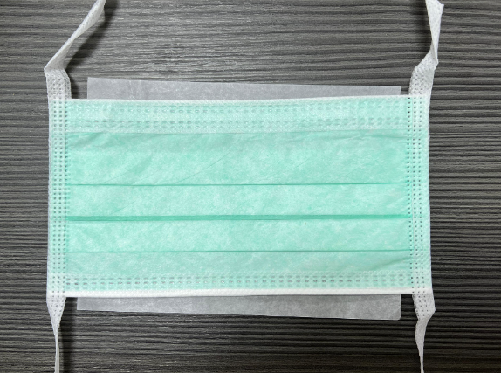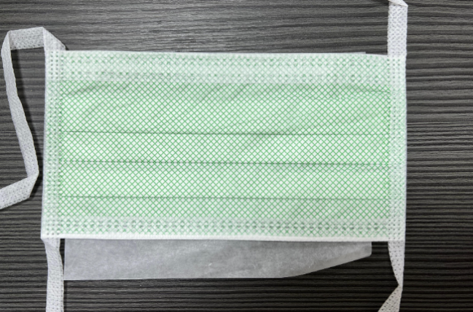
Figure 1: Current Mask Figure 2: Updated Mask
Part numbers affected:

Part No. | Description
15211  15212 | Surgical; Film; Anti-Fog; Green; ASTM Level 1; Non-Sterile; 50/Box; 6 Boxes/Case  Surgical; Tape; Anti-Fog; Green; ASTM Level 1; Non-Sterile; 50/Box; 6 Boxes/Case

Should you have any further questions please do not hesitate to reach out your dedicated sales rep or our Customer Service Department at 888-364-7004, customerservice@aspensurgical.com.

Thank you for your continued partnership,

Kushal Basnet
PRODUCT MANAGER
kushal.basnet@aspensurgical.com
6945 Southbelt Dr. SE, Caledonia, Michigan 49316 USA
aspensurgical.com

