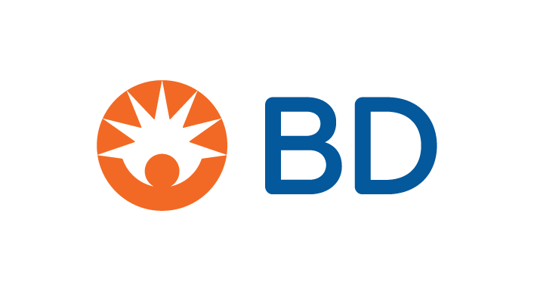

April 21, 2025

Dear Valued Customer,

Across BD, we routinely evaluate our product portfolio to ensure we are continuing to meet the needs of our customers – and patients – around the globe. As a result, we will be making strategic decisions affecting our product portfolio. We believe these decisions can offer you a heightened customer experience by increasing the predictability of supply and demand, as well as the speed at which we can deliver products to you. In addition, we believe this will enable the introduction of new, innovative products.

To support your own planning, we want to give you notice of the following product changes. Below is a list of upcoming discontinuations - please refer to the appendix for the specific list of impacted products purchased by your organization, the discontinuation timeline, and recommended alternate BD products.* You and others in your organization may also receive additional information from BD about these upcoming discontinuations.

|  |  |
| --- | --- |
| **Material** | **Discontinued Date** |
| Alaris Medley LVP Primary Admin Set  Select Alaris Medley LVP Primary Admin-15 mcrn Sets  Max Zero Extension Set  Various IV Access OEM - Private Label products | 01/11/2025  01/11/2025  01/10/2025  01/10/2025 |
| BD Pyxis™ CUBIE™ Mobile Dock  BD Pyxis™ CUBIE™ System Software | Effective immediately  Effective immediately |
| BD DifcoTM Inoculation Loops and Needles | 9/30/2025 |
| BD Clay Adams SurePrep Plain Capillary Tubes | 5/30/2025 |

BD appreciates and values your business and looks forward to your continued interest in our products. While we recognize this change may impact your organization, we are confident that any potential short-term impact will be offset by our commitment to providing innovative products, solutions, and services.

To best serve you, all inquiries and requests should be directed through your local sales representatives or by contacting BD Customer Service at 1-844-823-5433.

Sincerely,

Joseph DiCandilo

Group Vice President

Channel Management, U.S. Region

*The potential alternative or substitute products are BD’s suggestions based on its own comparison of the intended use, the form, features and functions of the discontinued products and the potential alternative or substitute products. Depending on a customer’s circumstances, clinical requirements and intended use of the proposed alternative or substitute product, such product may not be a clinically appropriate substitute or alternative to the discontinued product, and any such determination shall be made by the customer.