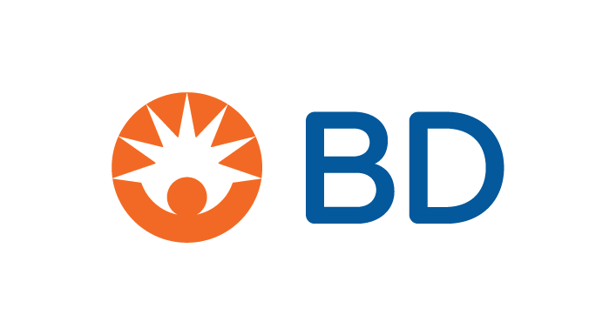

August 05, 2024

Dear Valued Customer,

Across BD, we routinely evaluate our product portfolio to ensure we are continuing to meet the needs of our customers – and patients – around the globe. As a result, we will be making strategic decisions affecting our product portfolio. We believe these decisions can offer you a heightened customer experience by increasing the predictability of supply and demand, as well as the speed at which we can deliver products to you. In addition, we believe this will enable the introduction of new, innovative products.

To support your own planning, we want to give you notice of the following product changes. Below is a list of upcoming discontinuations - please refer to the appendix for the specific list of impacted products purchased by your organization, the discontinuation timeline, and recommended alternate BD products.* You and others in your organization may also receive additional information from BD about these upcoming discontinuations.

|  |  |
| --- | --- |
| **Material** | **Discontinued Date** |
| 4 Alaris Medley LVP products  1 Alaris Plus product  5 Gravity Sets products 1  5 Gravity Sets products  1 Gravity Set product  4 Intravenous Access Extension Sets & Accessories  1 Hazardous Drug Safety | 03/31/2025  03/31/2025  Immediately  03/31/2025  05/31/2025  03/31/2025  03/31/2025 |
| Pyxis™ PARx system ² | 09/30/2029 |
| Product from the Peripheral portfolio | 03/31/2025 |
| Abramson Sump Drains 3  Select products from the Temperature Sensing Foley Catheter Strips & Trays 4 | 8/31/2024 |
| Medical Equipment Roll Stand 5 | Immediately |
| Brother printer paper (20 sheet cartridge) | 08/31/2024 |
| Various BBL™ Sensi-Disc products  One BD Difco™ Antiserum Product 6 | 01/01/2025  07/31/2024 |

1 - Production restrictions due to absence of set components for these group of SKUs  
2 - Pyxis™ PARx software versions 5.0 and 5.1 have previously been announced End of Life and have achieved End of Support.

3 - Supplier no longer able to provide necessary component

4 - Alternative products available

5 - Identical SKU available

6 - BD Difco™ Antiserum product will be discontinued due to technical challenges affecting our ability to manufacture.

BD appreciates and values your business and looks forward to your continued interest in our products. While we recognize this change may impact your organization, we are confident that any potential short-term impact will be offset by our commitment to providing innovative products, solutions, and services.

To best serve you, all inquiries and requests should be directed through your local sales representatives or by contacting BD Customer Service at 1-844-823-5433.

Sincerely,

Joseph DiCandilo

Vice President, Channel Management Group, U.S. Region

BD

*The potential alternative or substitute products are BD’s suggestions based on its own comparison of the intended use, the form, features and functions of the discontinued products and the potential alternative or substitute products. Depending on a Customer’s circumstances, clinical requirements and intended use of the proposed alternative or substitute product, such product may not be a clinically appropriate substitute or alternative to the discontinued product, and any such determination shall be made by the Customer.