Dear Valued Customer,

We are pleased to share that effective March 27, 2026, ExactaMix/ExactaMix Pro vented micro-volume inlet H938175 is removed from 100% allocation.

Table 1 | Allocation Status of ExactaMix/ExactaMix Pro Micro-Volume Inlet

Product Code | Product Description | Allocation Status | Effective Date
H938175 | ExactaMix/ExactaMix Pro Inlet. Vented, Micro-Volume Inlet | Off Allocation | March 27, 2026

We understand the importance of supply continuity and are committed to transparently and proactively communicating any changes in supply with you. To ensure you have the information you need, please visit the Supply Resources page on our website and download our Supply Availability Report to access the latest information on product supply.

Sincerely,

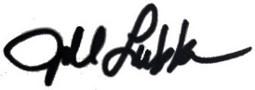

Jill Lubkeman
Vice President, U.S. and Canada Marketing – Infusion Therapies & Platforms
Baxter Healthcare Corporation

