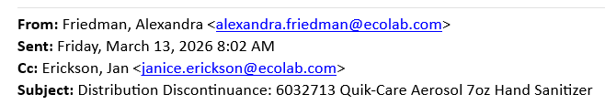
Greetings Distribution Partner.
Please accept this message as Ecolab Healthcare's formal announcement of the upcoming distribution changes for Ecolab's Quik-Care 7oz Aerosol Hand Sanitizer, 6032713). Due to ongoing supplier service constraints, inventory will be on allocation for direct orders only. Effective immediately, Ecolab Healthcare will cancel all indirect orders. Our team has already started reaching out to mutual end users impacted by these changes.
As for the recommended next steps, we would like to move customers to either Ecolab's Quik-Care Aerosol 15oz hand sanitizer (same formula in larger size) or one of our higher volume platforms as soon as possible. Here is a list of alternatives below and the no-charge manual dispenser details:
