

Subject: ISO 80369-5 Standard Frequently Asked Questions

Dear Valued Customer,

Thank you for your trust and confidence in GE HealthCare CRITIKON™ non-invasive blood pressure cuffs. Below you will find answers to commonly asked questions pertaining to the ISO 80369-5 transition.

**Question**: Why is GE HealthCare transitioning from the ISO 80369-1 DINACLICKTM connection system to the ISO 80369-5 DINACLICK connection system?

**Answer**: As a commitment to patient safety. GE HealthCare strives to provide you with quality healthcare products that meet the highest standards of patient safety.

**Question**: What is the ISO 80369-5 standard?

**Answer**: The ISO 80369-5 standard restricts the types of connectors used in blood pressure measurement to avoid the accidental connection of blood pressure machines with other equipment types.

**Question**: When did GE HealthCare begin shipping ISO 80369-5 DINACLICK connectors?

**Answer**: All blood pressure hoses and connectors shipped to customers for conversions and device maintenance since 2020 have included the ISO 80369-5 DINACLICK connector.

**Question**: Will GE HealthCare end of life the ISO 80369-1 DINACLICK connection system?

**Answer**: Yes, GE HealthCare will globally end of life all products that use our ISO 80369-1 DINACLICK connection system on June 30th, 2025.

**Question:** How can I tell the difference between an ISO 80369-1 cuff end and ISO 80369-5 cuff end?

**Answer:** The ISO 80369-5 cuff end include tabs whereas ISO 80369-1 cuff end does not. See graphic below.

|  |  |
| --- | --- |
| ISO 80369-1 cuff end | ISO 80369-5 cuff end |

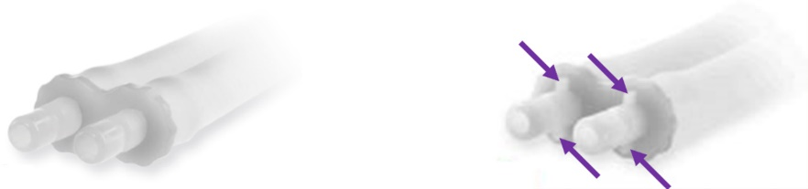

**Question**: Does the ISO 80369-5 DINACLICK connector appear visually different than the ISO 80369-1 DINACLICK connector?

**Answer**: Yes, the ISO 80369-5 DINACLICK connector is grey. See graphic below.

|  |  |
| --- | --- |
| ISO 80369-1  **Black** DINACLICK Connector | ISO 80369-5 Compliant  **Grey** DINACLICK Connector |

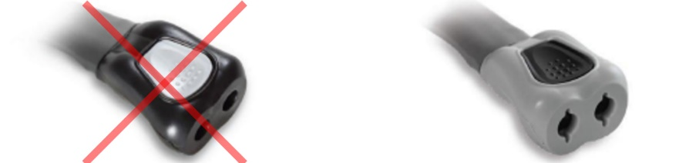

**Question**: Can I exhaust my inventory of ISO 80369-1 blood pressure cuffs in the transition to ISO 80369-5?

**Answer**: Yes, ISO 80369-1 cuff ends fit ISO 80369-5 DINACLICK connectors.

**Question**: Will there be a part number change?

**Answer**: Yes, ISO 80369-5 blood pressure cuff part numbers are easily identifiable with the -5S appended to the previous part number.

Example part number

ISO 80369-1: SFT-A2-2A

ISO 80369-5: SFT-A2-2A**-5S**

**Question**: Are ISO 80369-5 DINACLICK connectors currently available?

**Answer**: Yes, please work with your GE HealthCare Product Sales Specialist to convert any remaining black ISO 80369-1 DINACLICK connectors to the new standard grey ISO 80369-5 DINACLICK connectors.

If you have any additional questions, please contact your local GE HealthCare Product Sales Specialist.

Thank you,