From: Tzivya Reich <Tzivya.Reich@gericare.com>
Sent: Thursday, February 12, 2026 2:46 PM
To: Tricia Wentling <twentling@concordancehs.com>
Subject: Holiday Closure Notification

Hi Tricia,
I hope you are keeping safe and warm!
I wanted to give you a heads-up regarding Geri-Care’s upcoming Passover Holiday Schedule.
We will be closed April 1st through April 9th (see calendar below).
As we are working on ensuring the large influx of orders ship prior to our closing, we would need all orders placed on or before March 19th.
If you would like to be certain that your inventory needs are covered over the Holiday period, please feel free to increase your order quantities throughout February and early March.
Kindly confirm that this works on your end and feel free to contact me with any questions or concerns.

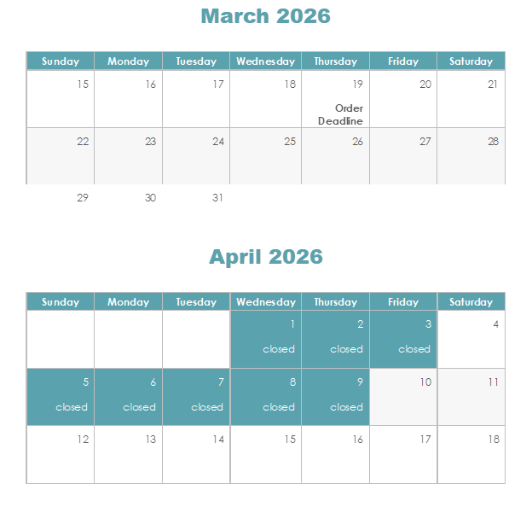
Thank you,

