November 27, 2024

Reference: Oxygen & Medication Delivery Product Discontinuation Notification

Dear Valued ICU Medical Distribution Partner,

This letter is to inform you that, as of December 31st, 2024, we will no longer be offering the Oxygen & Medication Delivery product range. Unfortunately, there will be no alternative options available for these products. Below, you will find a list of all the affected product codes.

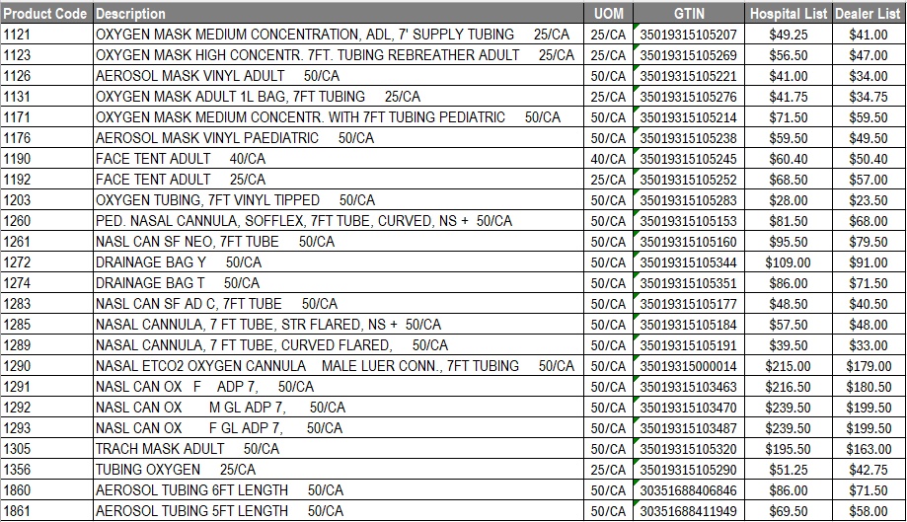

We sincerely appreciate your use of our products and apologize for any inconvenience experienced by patients or your customers. Please contact your sales representative or customer service team at 1-800-258-5361 with questions regarding this discontinuation.

Sincerely,

Aria Merlo
Aria Merlo
US Marketing Manager, Respiratory and Tracheostomy

