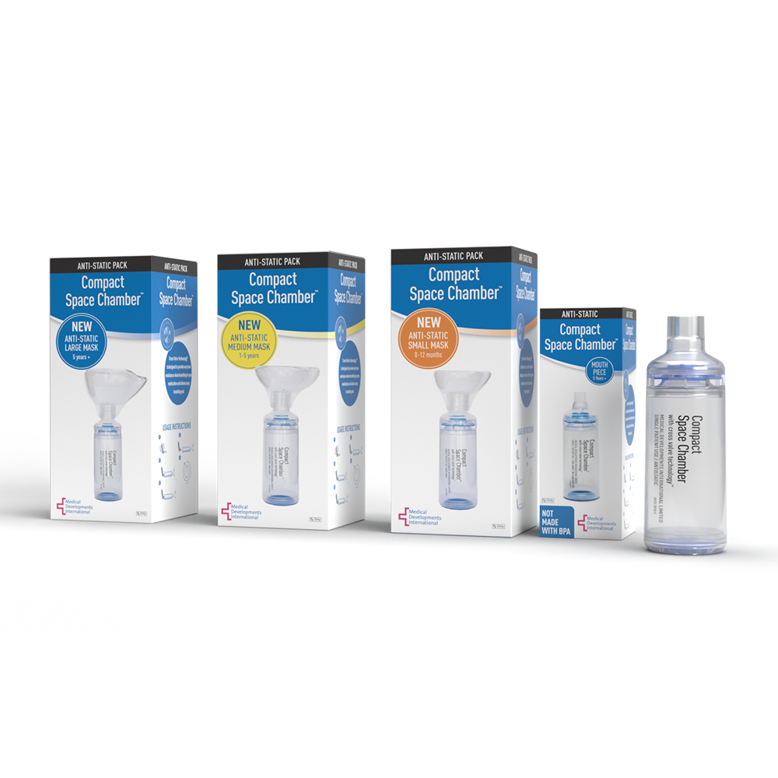

[www.medicaldev.com](http://www.medicaldev.com) [www.spacechamber.com](http://www.spacechamber.com)

Medical Developments International (MDI) offers a full line of patented high quality and low-cost respiratory devices for use with an Asthma/COPD Inhaler. Valved holding chambers/spacers are a medical device attached at the end of inhalers used to minimize medication waste and side effects. The benefits the anti-static space chamber and anti-static silicone face mask range include:

* Proprietary low resistance, one-way Cross Valve Technology TM –visible valve action through transparent chamber.
* Anti-static mask fits neonates, infants, children, adolescents, and adults available in S, M, L standard 22mm diameter fitting.
* Interchangeable masks and chambers.
* No priming required before use, BPA free, dishwasher safe, 1 year manufacturer guarantee.
* Covered by 98% of Commercial, Medicaid and Medicare with in-stock availability.

The respiratory product category spans across both the non-acute and acute space to include patients with COPD and/or asthma and is nondiscriminatory across all ages, sex, education levels and economics. A prescription is required, and clinical guidelines recommend use Globally. The MDI product line is utilized in both acute and nonacute spaces across DME, LTC, Skilled Nursing, IDN, and GPOs.



Medical Developments International is a Global manufacturer penetrating the US Market and offers the following:

1. McKesson 3PL consistent sourcing across the United States.
2. FDA 510K cleared.
3. Field and marketing support to align with partner initiatives.

Contact: **Steph Hall** National Key Account Manager Institutions [shall@medicaldev.com](mailto:shall@medicaldev.com) 803-220-6144