September 1, 2024

Dear Valued Distributor:

We are excited to announce great news! In November 2024, Vivonex® Pediatric Elemental Powder is being relaunched in a new and improved multi-serving canister with an easy-to-store scoop. Changing from the single-serve packets to the new multi-serving canister not only reduces paper and cardboard waste, but it also supports our ongoing efforts to improve the availability of products by optimizing our manufacturing capabilities. Plus, at least 68% of the plastic in the lid and scoop are produced from sugar cane, a renewable resource.
In addition, we have also improved the Vivonex® Pediatric Elemental Powder, and here are some highlights:
- Now also indicated for Chylous Ascites and Chylothorax
- Now hypoallergenic
- Now certified Halal

Discontinued  Product Description | Discontinued Product Code | Discontinued  Case UPC/GTIN Code | New Replacement  Product Description | New Replacement  Product Code | New Replacement  Case UPC/GTIN Code | Est.  In-Market Date
VIVONEX® PEDIATRIC Unflavored Powder  36 x 1.7 oz packets | 07131000 | 10043900713103 | VIVONEX® PEDIATRIC, Unflavored Powder  6 x 400 g canisters | 8445291507 | 08445291507654 | Dec. 2024

Distributor Price List – Acquisition Cost
The following chart reflects the Distributor Price List acquisition price for new item, effective November 1, 2024:
 | Access | Sub-Minimum | Bracket  1 | Bracket  2 | Bracket  3
Product Description | 1-124  cases  0 - 1,999  lbs | 125-349  cases  2,000 -  5,599 lbs | 350-1249  cases  5,600 -  19,999 lbs | 1250-1999  cases  20,000 -  31,999 lbs | 2000 -  Truckload  32,000+  lbs
VIVONEX® PEDIATRIC, Unflavored Powder  6 x 400 g canisters | $316.76 | $313.76 | $310.76 | $310.76 | $310.48

Street Price List – Contract Number 2482798
The following prices reflect the Street Price List chargeback point for the new item, effective
November 1, 2024:
Product Name | Product Code | Case UPC | Price per Case
VIVONEX® PEDIATRIC, Unflavored Powder 6 x 400 g canisters | 8445291507 | 08445291507654 | $310.63

Long-Term Care Program – Contract Number 2483959
The following prices reflect the Long-Term Care Program Price List chargeback points for the new items, effective November 1, 2024:
Product Name | Product Code | Case UPC | Price per Case
VIVONEX® PEDIATRIC, Unflavored Powder 6 x 400 g canisters | 8445291507 | 08445291507654 | $310.63
What Is Changing? | What Is NOT Changing?
- Servings/case goes from 36 to 49.5  - Price per case adjusted due to  increased calories per case  - Packaging  - UPCs, Product Codes and NDC-format numbers  - Micronutrient changes to reflect current Dietary Reference Intakes (DRIs)  - Case/pallet dimensions  - Now Halal certified  - No longer Kosher certified | - Price per calorie  - Macronutrient profile  - HCPCS code: B4161  - Shelf life: 24 months

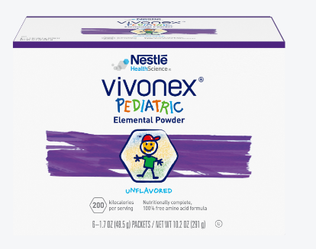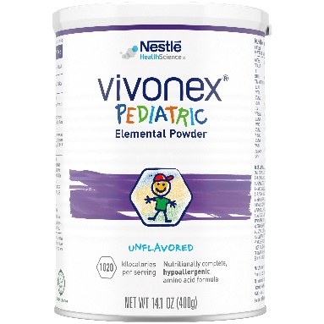

Should you have any questions or require additional information, please work with your Nestlé representative, or call our Consumer Service Center at 1-800-422-2752 that is staffed with Registered Dietitian Nutritionists (RDN). Additional product information and support tools can be found on our Medical Hub at www.nestlemedicalhub.com. If ordering through one of our distributor partners, please work directly with your distributor representative to order product.
You have our unwavering commitment to providing the highest quality solutions to enhance the health and well-being of those you care for.
Sincerely,
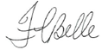
Felicia Belle
Vice President, Head of Sales
Nestlé Health Science, US

Attachments: Spec Sheet & Cross Reference

