**Subject: Quality Notification Memo**

Based on recent customer feedback, Angelini Pharma would like to make recommendations on the shipping of Alcavis 50 and Exsept Plus.

The feedback has been related to the leakage of the product listed above. Per the product labeling, it is recommended that the product remains upright. This will help prevent possible leakage and maintain the integrity of the product during transport.

In addition to the recommendation listed above, during our customer complaint process, there are a few components required (for example the product description and lot number). In an effort to assist with collecting this information, please see the photo below on where this information can be found. The lot number is crucial to providing a robust investigation of our manufacturing process.

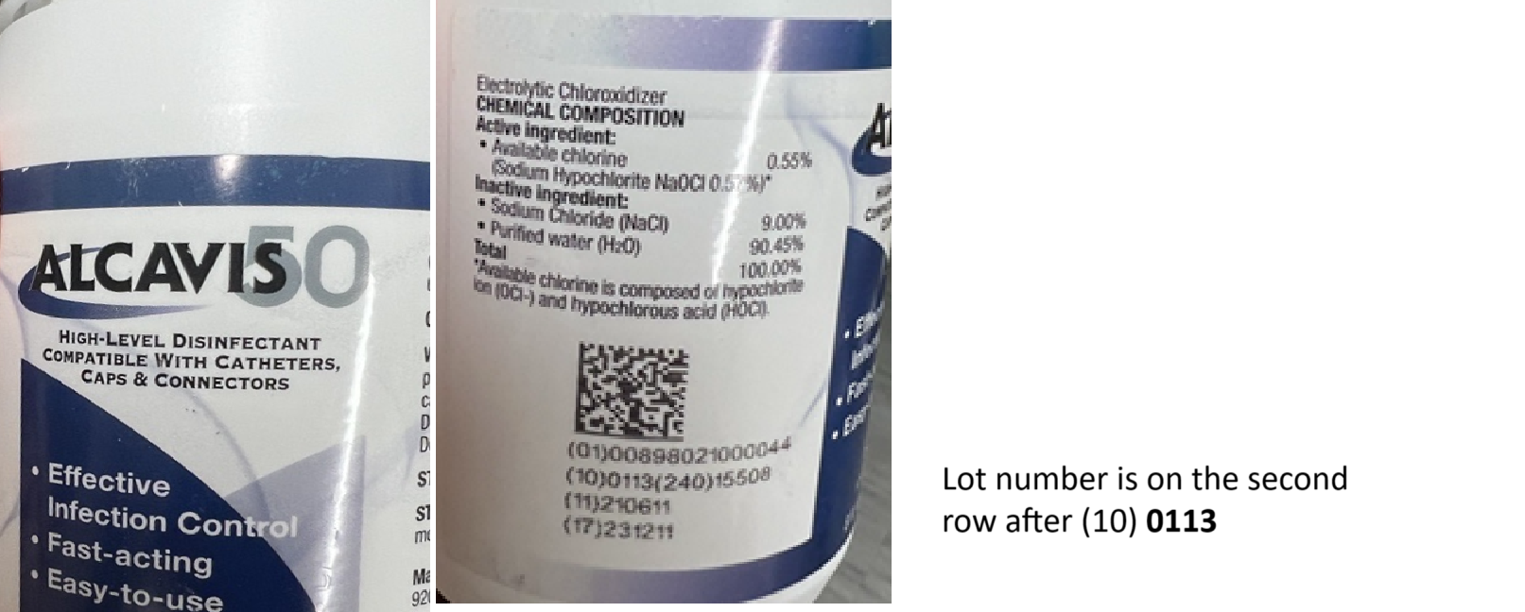

We appreciate your cooperation in this matter.

Kind Regards,

JoEllen Whitmire

Quality Assurance Specialist

|  |  |
| --- | --- |
| Angelini Pharma Inc |  |