
March 2026
Notice: Important Information Regarding Solventum ERP Transition
Dear Valued Customer,
Over the past several months, we have been working diligently to ensure a smooth and efficient transition from 3M to Solventum. During this period, 3M has continued to provide transitional support to Solventum while we develop our own infrastructure.
Following a comprehensive review by Solventum’s leadership teams, the Enterprise Resource Planning (ERP) deployment date has been revised to July 2026. We recognize the efforts made in preparation for this transition, and we want to acknowledge the impact this may have on your planning. We sincerely apologize for any inconvenience this change may cause and appreciate your understanding.
This decision reflects our commitment to ensuring a smooth transition that prioritizes service continuity and a robust operational foundation as Solventum continues working toward a successful transition. This extension will allow us to complete final testing of critical processes and tools and ensure we are prepared to deliver the high-quality service you expect and deserve.
We continue to build upon the significant progress made and appreciate your patience as some processes may take time to stabilize. Over the following months, we will provide you more details regarding the timeline, changes to our processes, and the information you will need to officially transition from 3M systems to Solventum.
Our customers remain our highest priority, and we are committed to providing strong service and support throughout this transition. Our customer service and sales teams will stay closely connected with you to ensure a smooth process.
Thank you for your continued support of Solventum products and helping us improve lives worldwide. We truly appreciate your partnership and collaboration during this time. If you have any questions, please reach out to your Solventum representative.
Please share this notification with all relevant individuals in your organization.
Best Regards,
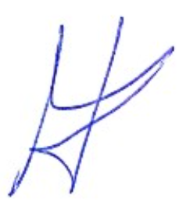
Laszlo Svinger
Vice President, Global Commercial Operations
Solventum

