**Product Updates Bulletin – 3/7/2025 – Instruments Division**

**Obsolescence/No Longer Shipping**

If you require cancellation of open lines for obsolete products, please let us know as soon as possible.

**NEW/CRITICAL:**

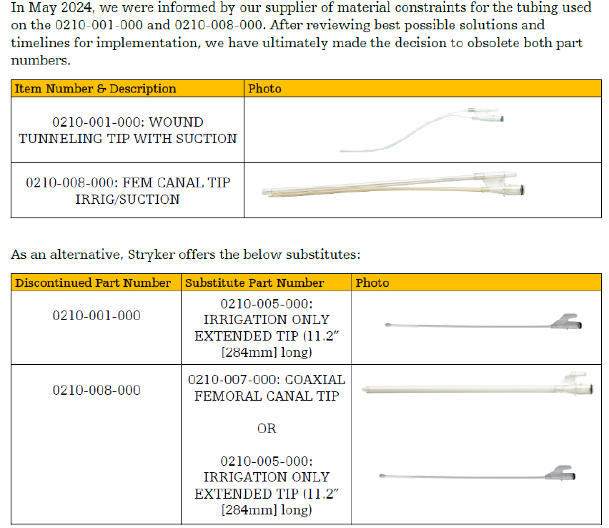

**2296-101-423** is obsolete. The best available sub is **1608-002-009**. See below for comparison. This substitute will be compatible with the Micro Drill.

